EXPERIMENT -4

Scrum Project in Jira
Project: Airline Management System (AIR)
Name | M.Ramprasadh
Register No. | 192511355
Course Code | CSA1007
Date | 12 October 2026
Tool Used | Jira Software (Atlassian Cloud) – Scrum template
Project Name | Airline Management System
Sprint Lregth | 1 Week

1.Create a Scrum Project in Jira.
• Add a backlog with at least 5 items (e.g., "Create user registration page", "Develop API for login").
• Prioritize the backlog and create a 1-week sprint.
• Move backlog items into the sprint and start the sprint.
• Finally show the Screenshot of the sprint board at the start and end of the sprint.

Aim

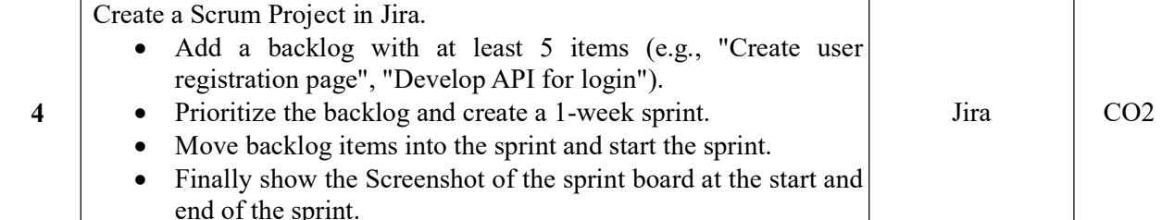

2. Tools Used
- Jira Software (Atlassian Cloud) – Scrum template
- Web browser (Google Chrome)

3. Procedure
- Log in to Jira. Open the Atlassian Jira site and sign in with your account.
- Create a Scrum project. Click Spaces (or Projects) in the left sidebar, choose Create space/project, and select the Scrum template.
- Name the project. Enter the name “Airline Management System” with the key “AIR”, then click Create. Jira opens the project with an empty Scrum board.
- Open the Backlog. Click the Backlog tab in the top navigation. The backlog lists work items that are not yet in a sprint.
- Add backlog items. Click + Create and add six work items (type: Story/Task):
- AIR-1 – Create User Registration Page
- AIR -2 – Develop Login Functionality
- AIR -3 – Develop Flight Search Page
- AIR -4 – Implement Flight Booking
- AIR -5 – Integrate Online Payment
- AIR -6 – Test Airline Reservation System
- Prioritize the backlog. Set the priority of each item: AIR -1 as Highest, AIR -2 and AIR -3 as High, and AIR -4, AIR -5 and AIR -6 as Medium. Drag the items so the most important ones are at the top of the backlog.
- Create a sprint. Click Create sprint in the backlog. A new sprint (for example “AIR Sprint 1”) appears above the backlog.
- Add items to the sprint. Drag all six backlog items into the sprint.
- Set the sprint duration. Click Start sprint, choose a duration of 1 week, set the start and end dates, and enter a sprint goal.
- Start the sprint. Click Start. Jira opens the Active sprints board, where all six items appear in the TO DO column (see Figure 1).
- Work through the sprint. During the sprint, drag items across the columns to simulate progress: AIR -3 and AIR -4 move to IN PROGRESS, and AIR -1 and AIR -2 move to DONE. AIR -5 and AIR -6 stay in TO DO.
- Capture the screenshots. Take one screenshot of the board at the start of the sprint and one near the end of the sprint (see Section 5).

4. Backlog and Sprint Progress
The table shows each backlog item, its priority, and its status on the sprint board at the start and at the end.
Key | Backlog Item | Priority | Status at Start | Status at End
AIR -1 | Create User Registration Page | Highest | To Do | Done
AIR -2 | Develop Login Functionality | Highest | To Do | Done
AIR -3 | Develop Flight Search Page | High | To Do | In Progress
AIR -4 | Implement Flight Booking | High | To Do | In Progress
AIR -5 | Integrate Online Payment | Medium | To Do | To Do
AIR-6 | Test Airline Reservation System | Medium | To Do | To Do

5. Output Screenshots
5.1 Jira Backlog and Sprint Planning

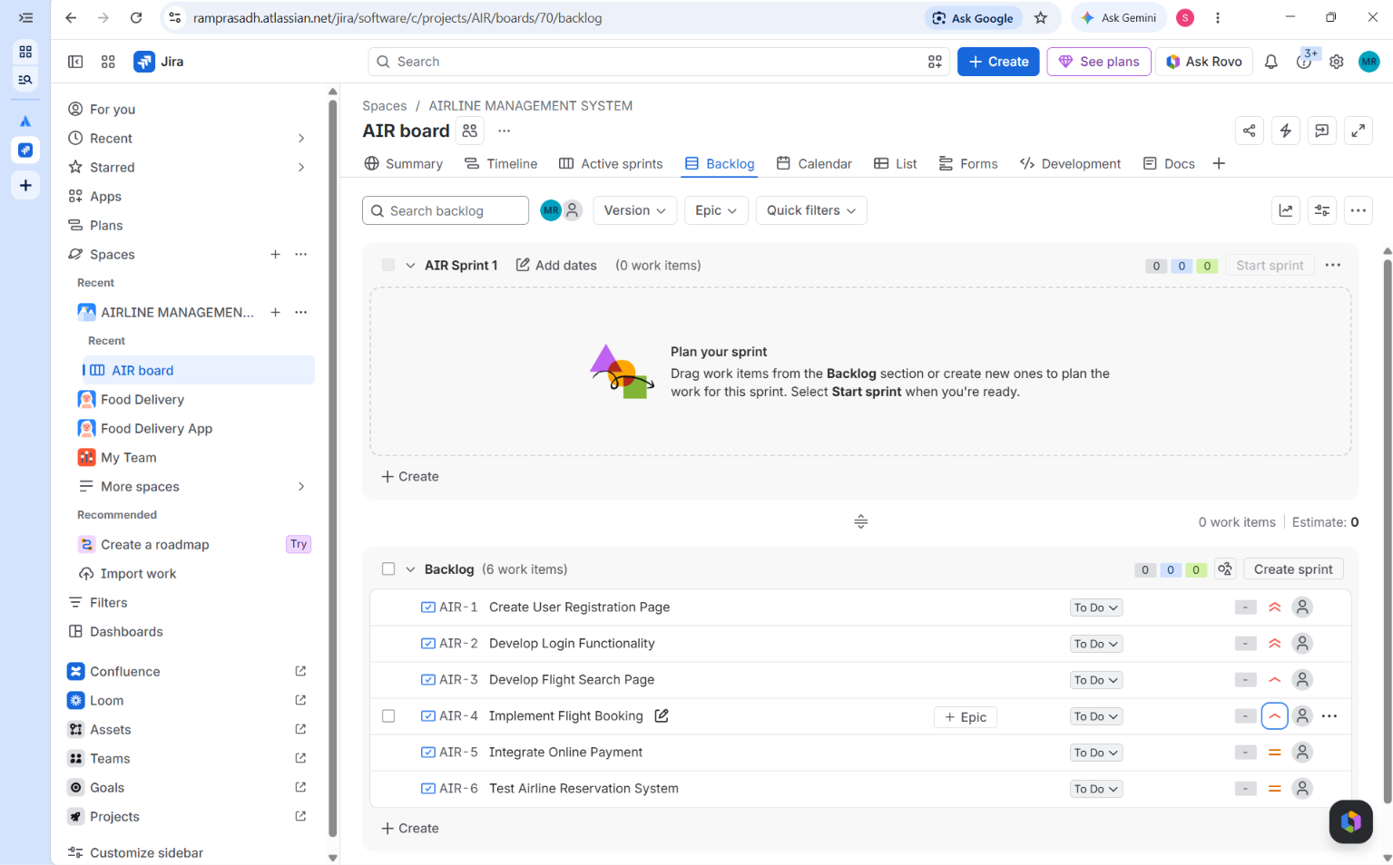
5.2 Jira Backlog Before Starting the Sprint

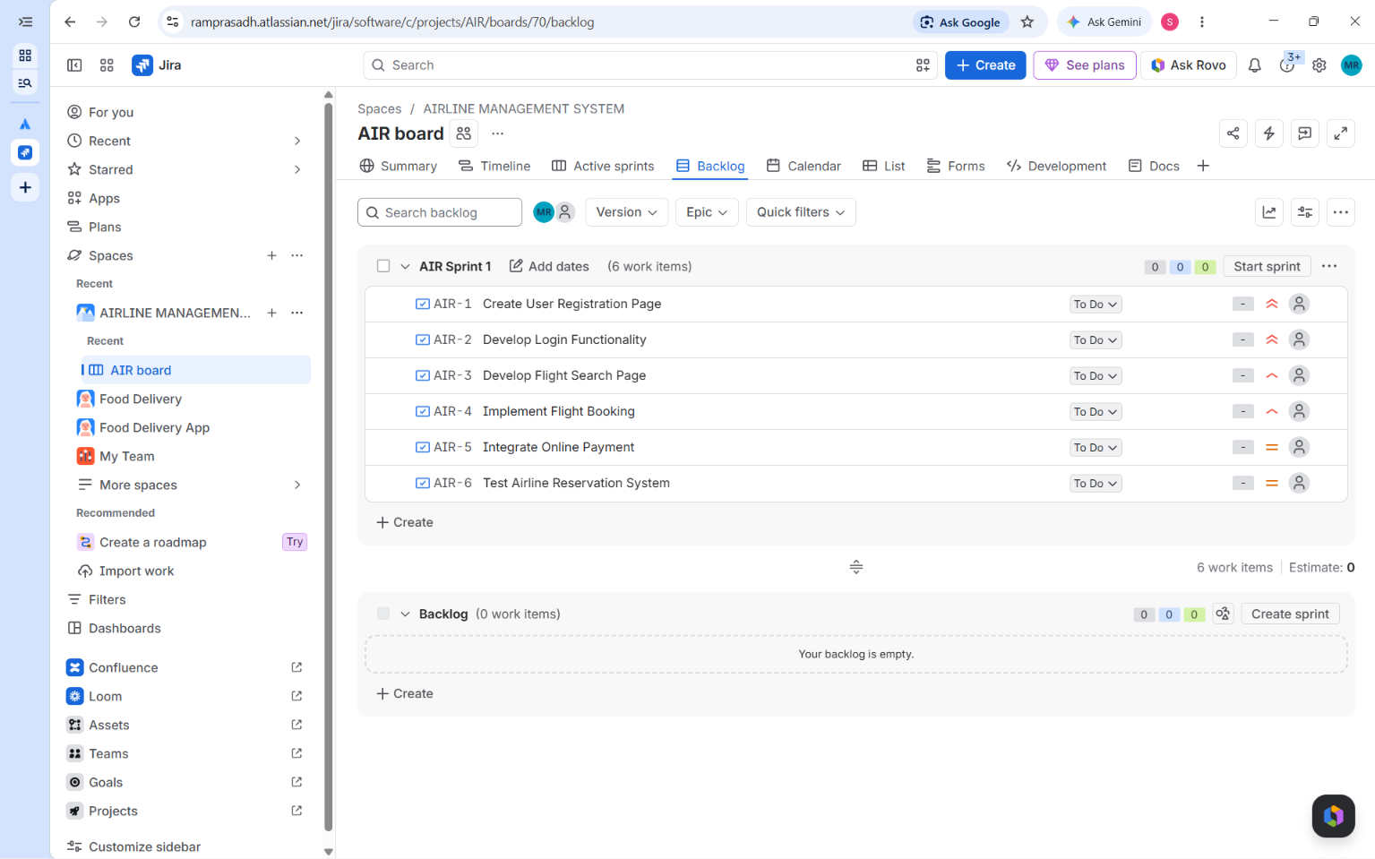
5.3 Sprint board at the start of the sprint
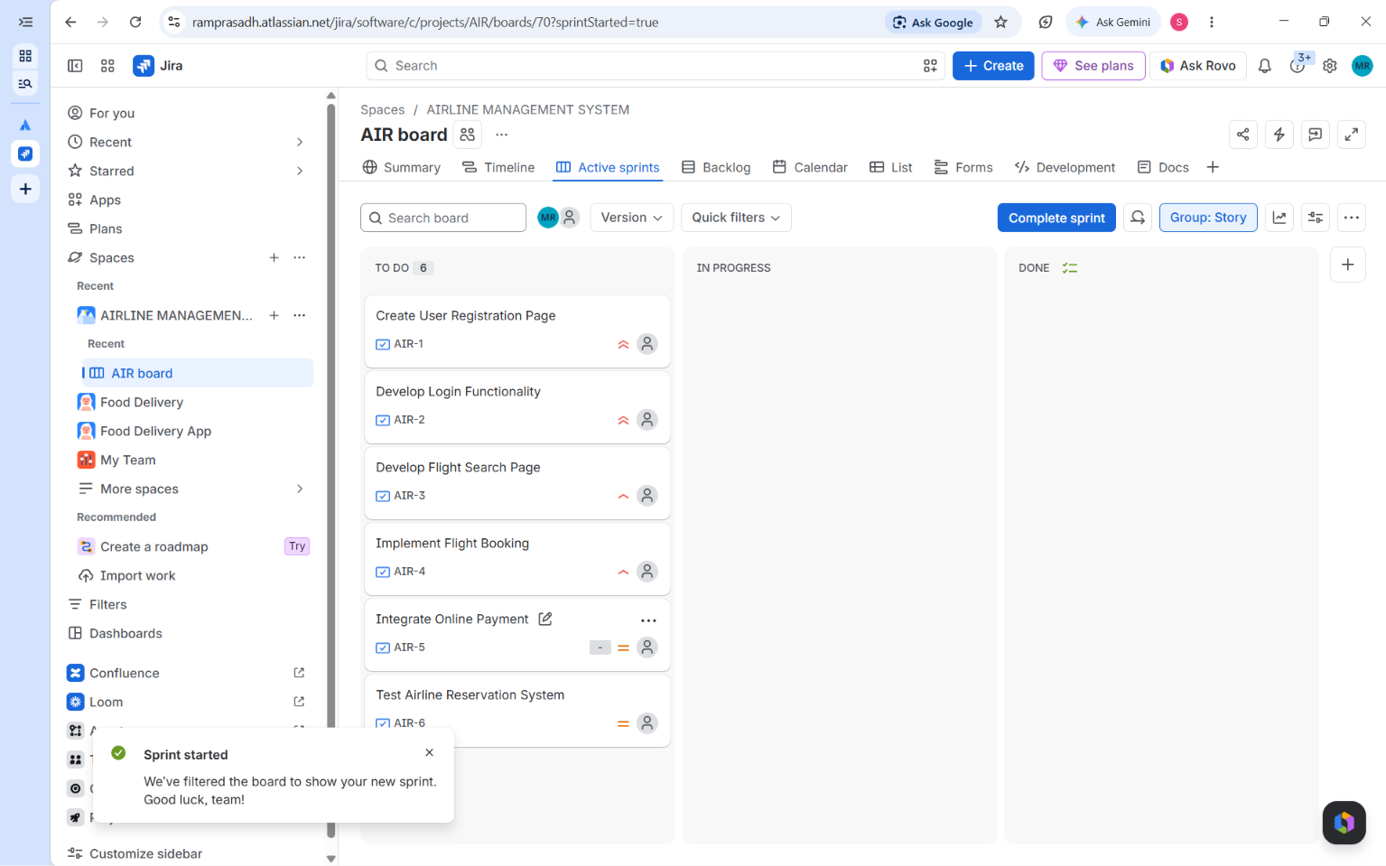
5.2 Sprint board at the end of the sprint
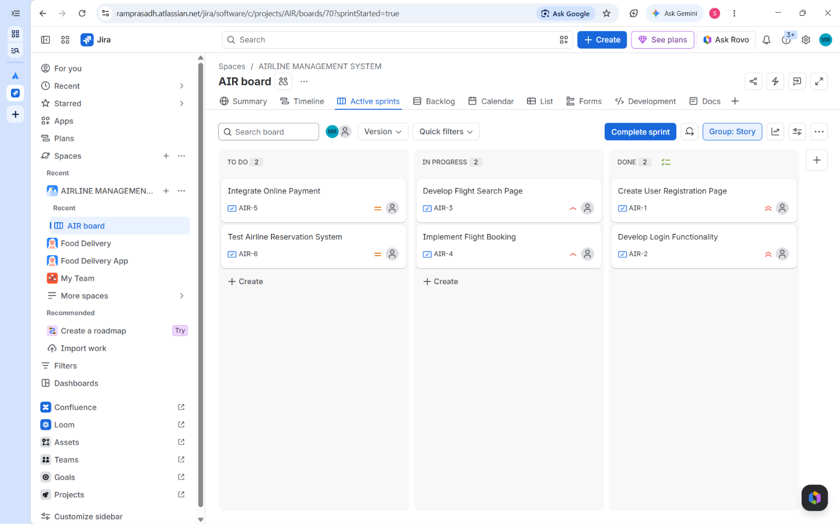

6. Result
A Scrum project was created in Jira with a prioritized backlog of six items. A one-week sprint was created and started with all six items, and the sprint board was captured at the start and at the end of the sprint. By the end, AIR-1 and AIR-2 were Done, AIR-3 and AIR-4 were In Progress, and AIR-5 and AIR-6 were still in To Do.

7. Conclusion
The experiment shows the basic Scrum workflow in Jira: a prioritized backlog, a time-boxed sprint, and a sprint board that makes progress visible. Comparing the start and end boards shows how work moves from To Do to In Progress to Done over the sprint.

